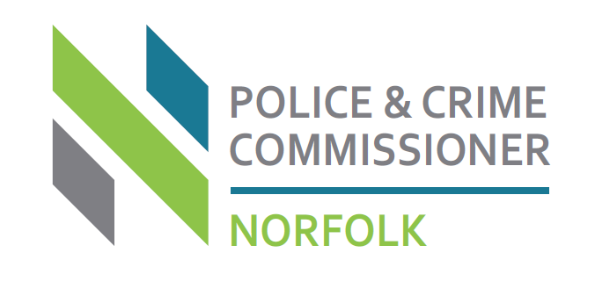
Ministry of Justice Funding for Domestic Abuse and Sexual Violence Support Services April 2022
Introduction
The Ministry of Justice (“MoJ”) has announced ringfenced funding of £15.7m for 22/23 for domestic abuse and sexual violence support services. This funding will be distributed via Police and Crime Commissioners and their offices through local processes.

Successful recipients will be provided with three-year funding ending March 31, 2025.

An indicative total funding award for provision across the whole county has not been provided. The MoJ will allocate funds based on an assessment of local need.

The MoJ requires Police and Crime Commissioners to carry out ‘due diligence’ of all organisations who bid. Those organisations who are not already funded through the OPCCN will be required to provide details as per the Office of the Police and Crime Commissioner for Norfolk’s (OPCCN) Check List.

Norfolk Process
To be considered for funding you will need to:
- Email an Expression of Interest to the OPCC (email below) and this needs to provide a brief summary of what the applicant intends to bid for and an indicative amount.
- Complete the Application Form answering each section in turn. Please ensure all answers are as brief as possible (you can use bullet points) so as to comply with the return form (excel) to the MoJ.
- Submit the Application Form by 10 am on Tuesday May 3 to opccngrants@norfolk.police.uk Any bids received after this deadline cannot and will not be considered
- Provide documents within the Check List for consideration for those organisations that are not already funded by the OPCCN (embedded at the end of this document)
Domestic Abuse and Sexual Violence Funding Conditions
What type of organisations can apply – are we eligible?
Organisations do not need to be a registered charity, a charitable incorporated organisation, or a social enterprise to be eligible for this funding. However, if you have not been in a funding relationship with the Norfolk OPCC previously you will be subject to due diligence checks which will include a Fraud Risk Assessment. This will also require you to demonstrate that you have robust and safe operating practices, governance and management arrangements in place to support vulnerable victims of crime. It will also require you to submit copies of last year’s financial accounts and documents/policies as per the OPCCN Check List. (link below)
Organisations MUST provide tailored support services to help victims of domestic abuse, rape, sexual violence or sexual abuse and their families cope with the impacts of crime, and, as far as possible, recover from the harm they have experienced. These victims must live in the county of Norfolk.
Honour-based abuse falls within the government definition for domestic abuse.
Stalking carried out by a former intimate partner or by a family member falls within the government definition for domestic abuse
Any organisation that provides tailored support to victims of domestic abuse and their families is recognised as a domestic abuse support service.
Please note unlike with the Covid-19 extraordinary funding, this funding can be allocated to other public bodies, as well as to third sector organisations and to fund directly commissioned posts, as long as this can be justified within the local needs assessment and funding criteria.
What can organisations spend this money on?
To be eligible for DA and SV ringfenced funding, the organisation must provide tailored support to female and/or male victims who have experienced domestic abuse, rape or sexual abuse at any point in their life. This includes adults and children. The funding can be used to support existing clients as well as new referrals.
Funding can be used to provide support to domestic abuse and sexual violence victims and their families. Support services could include, but are not limited to:
- IDVAs or ISVAs
- Child IDVAs or Child ISVAs
- Court or family support
- Face to face or remote counselling for individuals and/or their families; and
- Support for particular groups such as BAME/Disabled/LGBT/male victims.
- Funding must be used to support victims who live in the county of Norfolk

What is excluded from the funding?
This funding cannot be used to provide accommodation or the support services within it. Funding for support for victims of DA in safe accommodation is subject to a separate funding process run by Department for Levelling Up, Housing and Communities (DLUHC).
Funding cannot be used for any of the following activities:
- campaigning activities (this fund is to support the delivery of direct services for vulnerable people)
- religious activities outside of projects benefiting the wider community and not containing religious content
- political or lobbying activities.
- loan repayments; or
- activities that make profit for private gain

Funding cannot be used for elements that fall outside of the scope of this fund; these are:

- perpetrator interventions
- support for victims of any other crime type
- capital works e.g., building repairs but can be used for other capital costs such as ICT equipment to enhance communications and help reach local people.
- funding used to pay for goods or services that have been bought or ordered before 1 April 2022 or after 31 March 2023.
- Funding to be used to pay for any outstanding debts prior to 1 April 2022.

What conditions will be put on the funding?
All funding will be provided by the Norfolk OPCC. This means if you are awarded funding, you will be required to adhere to terms and conditions within our Grant Agreement. A draft of our Grant Agreement is embedded within this document for you to review.
Schedule 1 of the Grant Agreement covers the following areas:
- Purpose
- Key deliverables
- Output
- Outcomes/targets
- Financial Information (award and breakdown)

Schedule 2 of the Grant Agreement covers the Payment Schedule
Schedule 3 of the Grant Agreement covers a detailed breakdown of spend

It should be noted that as part of the Grant Agreement, you will be required to:

- Provide financial data and outcome monitoring by a specified date every three months by way of a Grant Monitoring Report
- Provide financial and outcome data for the Ministry of Justice outcomes matrix twice per year (covering Apr-Sept and Oct-March) -draft attached
- Attend quarterly Grant Monitoring meetings to review the grant monitoring reports and project/service
- Provide details of underspends will be required at each year end and these will be required to be returned to the OPCCN. Funding cannot be carried forward between financial years. Any overspend will be the responsibility of the Grant holder.

As part of the Grant Agreement Terms and Conditions, for domestic abuse projects/services it will be mandatory that all services provided have agreed integrated referral and support pathways with the county’s Domestic Abuse Service ‘NiDAS’.

NiDAS is commissioned by the Office of the Police and Crime Commissioner as lead commissioner with partner contributions from Norwich City Council, Broadland and South Norfolk District Councils, Adult Social Services and Children’s Services.

What are the timescales?

These are as follows:

ACTION | DATE
Expressions of interests and application forms returned to OPCCN | Tue 3rd May 2022 - 10:00 hrs
Funding offers communicated to PCCs | Friday 20th May
Funding offers communicated to applicants | w/c 23d May

Please note if the MoJ are delayed in their communication to PCC’s this will have a knock-on effect for information that will be communicated to applicants.

A requirement from the MoJ is that a listing of all submitted bids will be displayed on the Norfolk Police and Crime Commissioner’s Website: www.norfolk-pcc.gov.uk

List of associated documents:

- Application Checklist
- Draft Grant Agreement – highlighted sections for reference only
- Application checklist
- Application Form
- MOJ Reporting Matrix

